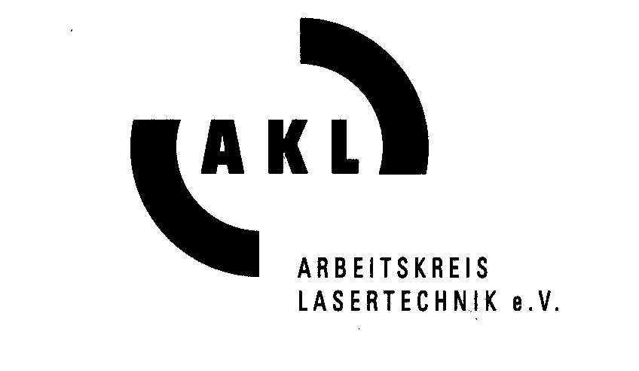

PRESS RELEASE Aachen, 7th May 2014

Dr. Ralf Preu, Fraunhofer Institute for Solar Energy Systems ISE:

Prize Winner of the Innovation Award Laser Technology 2014

The Innovation Award Laser Technology 2014, initiated by the associations Arbeitskreis Lasertechnik e.V. and the European Laser Institute ELI and provided with 10 000 Euros prize money, has been conferred to Dr. Ralf Preu, director of the division “Photovoltaics – Production Technology and Quality Assurance” of the Fraunhofer Institute for Solar Energy Systems ISE in Frei-burg (Germany) on 7th May 2014 in Aachen´s town hall. Dr. Ralf Preu and his team have got the first place in the open prize competition with the innovation “Laser Fired Contact (LFC) technology for the production of highly efficient silicon solar cells”. The jury composed by 9 international experts has selected 3 finalists among the 23 submitted applications. In the historical ambience of the »Coronation Hall« around 300 guests attended the awarding ceremony.

Dr. Paul Hilton, speaker of the international jury, pointed out the dedicated work of all 3 finalist´s and the outstanding innovations of the project teams in the field of laser technology.

The jury conferred the 1st prize of the Innovation Award Laser Technology 2014 provided with 10 000 € prize money to Dr. Ralf Preu, director of the division “Photovoltaics – Production Technology and Quality Assurance” of the Fraunhofer Institute for Solar Energy Systems ISE in Freiburg (Germany) and his team for the innovation “Laser Fired Contact (LFC) technology for the production of highly efficient silicon solar cells”. By the use of the LFC process the industrial partner set several technological world records. Regarding cell and module efficiencies 19,5% for a large area multi-crystalline silicon solar cell and 18,5% for a standard sized module were achieved. In the meantime approximately 1 million photovoltaic modules with Laser Fired Contacts are produced and installed. The outstanding performance of these modules compared to standard technology has been confirmed in several field tests.

The Fraunhofer ISE in Freiburg is an institute of the Fraunhofer Gesellschaft and contributes with its 1300 strong workforce and the cooperating industrial partners to innovations for a more efficient and environmentally friendly energy supply.
The prize winner Dr. Ralf Preu has been awarded the title of »AKL Fellow« and »ELI Fellow«. The certificates for the first, second and third placed finalist teams were handed over by Dipl.-Ing. Ulrich Berners, president of the Arbeitskreis Lasertechnik AKL e.V. and Dr. Paul Hilton, president of the European Laser Institute ELI.
The Innovation Award Laser Technology is a European research prize awarded at 2-yearly intervals by the associations Arbeitskreis Lasertechnik e.V. and the Euro-pean Laser Institute ELI. The award can be conferred on an individual researcher or on an entire project group, whose exceptional skills and dedicated work have led to an outstanding innovation in the field of laser technology. The scientific and technolo-gical projects in question must center on the use of laser light in materials processing or the methods of producing such light, and must furthermore be of demonstrable commercial value to industry.

The international jury selected on the basis of merit and the published criteria
3 outstanding finalists among the 23 applications for the Innovation Award Laser Technology 2014 (see detailed descriptions of the three innovations including photos on www.innovation-award-laser.org ). The 3 finalists and their teams listed in final ranking:
1st Place
Laser Fired Contact (LFC) technology for the production of highly
efficient silicon solar cells
Team:
Dr. Ralf Preu, Fraunhofer Institute for Solar Energy Systems ISE,
Freiburg, D (Team Representative)
Dr. Jan Nekarda, Fraunhofer Institute for Solar Energy Systems ISE,
Freiburg, D
Dipl.-Phys. Martin Graf, Fraunhofer Institute for Solar Energy Systems ISE,
Freiburg, D

2nd Place
Penetration Depth and Topography Measurement in Laser Materials
Processing using Low Coherence Interferometry
Team:
Dr. Markus Kogel-Hollacher, Precitec Optronik GmbH, Neu-Isenburg, D
(Team Representative)
Dr. Stephan Bichmann, Scheidt & Bachmann GmbH, Mönchengladbach, D
Dipl.-Phys. Niels König, Fraunhofer IPT, Aachen, D
M.Sc. Guilherme Mallmann, Fraunhofer IPT, Aachen, D
Dipl.-Ing. Thibault Bautze, Precitec GmbH & Co. KG, Gaggenau, D
Dipl.-Ing.(FH) Christian Fraas, Precitec Vision GmbH&Co.KG, Neftenbach, CH

3rd Place
FEMTOPRINT: A femtosecond laser printer for three-dimensional micro-
and nano-manufacturing of glass
Team:
Dr. Yves Bellouard, Eindhoven University of Technology, NL
(Team Representative)
Dr. Clemens Hönninger, Amplitude Systèmes, Pessac, F
Eric Mottay, Amplitude Systèmes, Pessac, F
Stefano Bottinelli, Mecartex SA, Muzzano, CH
Michael Hopper, Quintenz Hybridtechnik GmbH, Neuried, D
Dr. Jean-Marc Breguet, CSEM, Neuchâtel, CH
Dr. François Barrot, CSEM, Neuchâtel, CH
Prof. Peter Kazansky, University of Southampton, UK
Prof. Reymond Clavel, EPFL, Lausanne, CH
Dr. Rainer Kling, ALPhANOV, Bordeaux, F
Dr. John Lopez, ALPhANOV, Bordeaux, F
Nicoletta Casanova, FEMTOprint SA, Muzzano, CH

The 9 members of the international jury of the Innovation Award Laser Technology 2014 have been recruited from industry and the research community:
• Dr. Guido Bonati (Coherent LaserSystems GmbH+CoKG, Göttingen, Germany
• Dr. Guido Hennig (Daetwyler Graphics AG, Bleienbach, Switzerland)
• Dr. Paul Hilton (The Welding Institute TWI Ltd, Cambridge, United Kingdom)
• Prof. Dr. Veli Kujanpää (VTT Technical Research Centre of Finland,
Lappeenranta, Finland)
• Prof. Dr. Peter Loosen (Lehrstuhl Technologie Optischer Systeme TOS,
RWTH Aachen University, Germany)
• Dr. Filip Motmans (VITO NV, Mol, Belgium)
• Prof. Dr. José Luis Ocaña (Centro Láser, Universidad Politécnica de Madrid,
Spain)
• Prof. Dr. Andreas Ostendorf (Lehrstuhl für Laseranwendungstechnik, Ruhr-
Universität Bochum, Germany)
• Dr. Joseph Pankert (Philips Photonics, Aachen, Germany)

Further information:
- Regarding the award and the finalists: www.innovation-award-laser.org
Descriptions of the realized innovations of the 3 finalists and photos of the
awarding ceremony on 7th May 2014 in Aachen´s town hall can be
downloaded here.
Contact person: Axel Bauer, General Secretary of Arbeitskreis Lasertechnik
- Regarding Arbeitskreis Lasertechnik AKL e.V.: www.akl-ev.de
Contact person: Axel Bauer, General Secretary of Arbeitskreis Lasertechnik
Phone: +49/241/8906-194, Mobile: +49/170/3309769, Fax: +49/241/8906-112,
Email: axel.bauer@akl-ev.de
- Regarding European Laser Institute ELI: www.europeanlaserinstitute.org
Contact person: Dr. Paul Hilton, President of the European Laser Institute,
Phone: +44/1223 899000, Fax: +44/1223 892588
Email: contact@europeanlaserinstitute.org
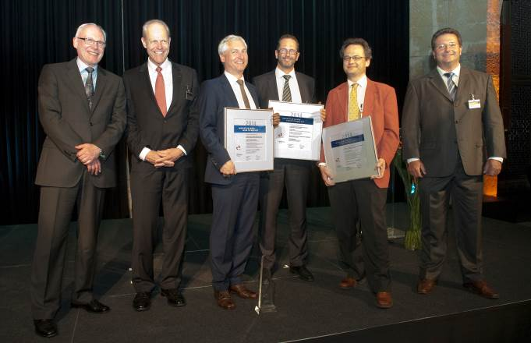  Dr. Paul Hilton, President of the European Laser Institute ELI, Prof. Reinhart Poprawe, Director of the Fraunhofer ILT, Dr. Markus Kogel-Hollacher, Precitec Optronic GmbH, Speaker of the second-placed team, Dr. Ralf Preu, Fraunhofer Institute for Solar Energy Systems ISE, Speaker of the winner-team, Dr. Yves Bellouard, Eindhoven University of Technology and Speaker of the third-placed team, Dr. Ulrich Berners, President of the Arbeitskreis Lasertechnik e.V.  Copyright: Fraunhofer ILT, Aachen / Heike Lachmann. | Picture 1:  Finalist teams of the Innovation Award Laser Technology 2014: (l.t.r.):

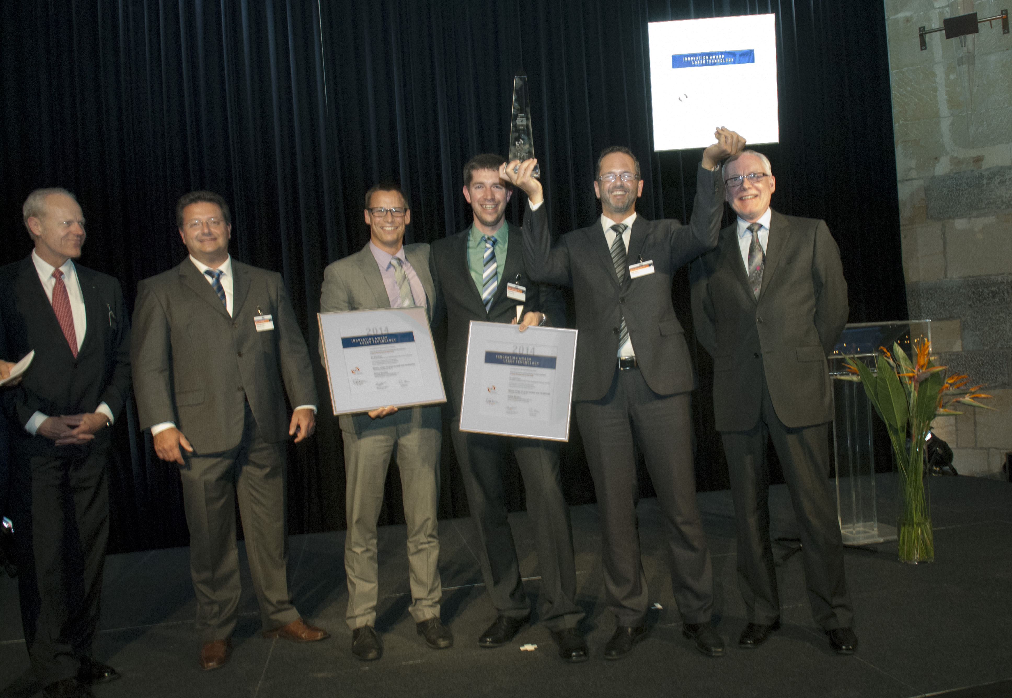  Prof. Reinhart Poprawe, Director of the Fraunhofer ILT, Dr. Ulrich Berners, President of the Arbeitskreis Lasertechnik e.V. , Winning Team: Dr. Jan-Frederik Nekarda, Martin Graf, Dr. Ralf Preu from Fraunhofer Institute for Solar Energy Systems ISE, Dr. Paul Hilton, President of the European Laser Institute ELI.  Copyright: Fraunhofer ILT, Aachen / Heike Lachmann. | Picture 2:  Winning Team of the Innovation Award Laser Technology 2014: (l.t.r.):

